

**SCHOOL OF PHYSICS**

# UNIVERSITI SAINS MALAYSIA

**ZCT191/192 PHYSICS PRACTICAL I/II**

1TS2 THERMOELECTRIC EFFECT AND THERMAL CONDUCTIVITY

***Lab Manual***

# OBJECTIVES

1. *To investigate the relationship between electromotive force (EMF) and the thermocouple’s*

*temperatures within* 0*–*100 °C*;*

1. *To use a thermocouple as a thermometer and investigate the characteristic of a two-junction thermocouple within* 0–400 °C*; and*
2. *To estimate the thermal conductivity of solid materials by measuring the thermal energy in conduction.*

# THEORY

### Thermocouples

*Thermocouples* are temperature sensors made from two different metals. A voltage is generated when these metals are brought together to form a *junction*, creating a temperature gradient between them. This phenomenon was discovered in 1822 by *Thomas Seebeck* (German physicist), where he took two different metals at different temperatures and made a series circuit by joining them together. He found that this circuit generated an electromotive force (EMF), and the larger the temperature differences between the metals, the higher the generated voltage. His discovery is known as the *Seebeck effect*, and it is the basis of all thermocouples.

The voltage produced in the Seebeck effect is proportional to the temperature difference between the two junctions at low temperatures. The proportionality constant 𝛼 is known as the *Seebeck coefficient*, it can be found by finding the gradient when plotting the voltage against the temperature (thus has the units of V K−1).

### The Law of Intermediate Materials

The *law of intermediate materials* was originally known as the law of intermediate metals. This law states that the sum of all the EMF in a thermocouple circuit using two or more different metals is zero if the circuit is at the same temperature. This law is interpreted to mean that the addition of different metals to a circuit will not affect the voltage the circuit creates, provided they are at the same temperature as the junctions in the circuit. This means that a third metal (e.g. a copper wire) may be added to the circuit to allow measurements to be taken. This allows thermocouples to be used with digital multimeters, or be soldered to join the metals.

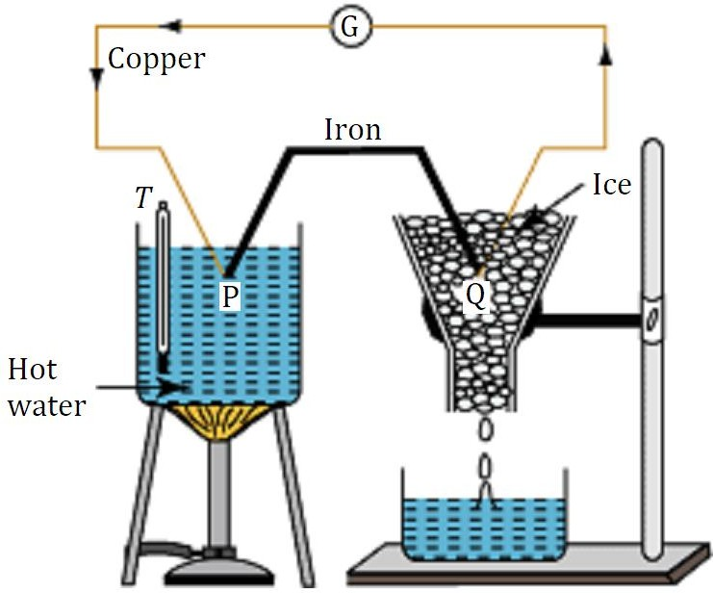

**Figure 1**: A setup of a Cu/Fe thermocouple.

### Thermo EMF vs. Temperature

The thermo EMF in a thermocouple increases if the temperature of the *hot junction* is increased, while the *cold junction* (usually kept at 0 °C) is kept constant. Consider a copper-iron (Cu/Fe) thermocouple with the hot junction (P) placed in a hot water bath, while the cold junction (Q) kept in ice (**Figure 1**). A deflection in the galvanometer (G) measures the thermo EMF, while the thermometer measures the temperature 𝑇 of the water bath.

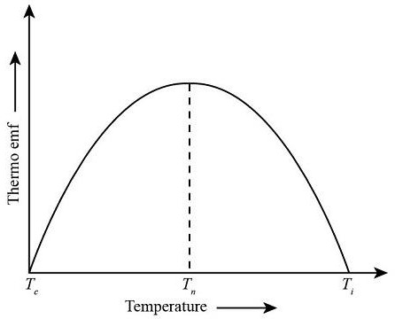

**Figure 2**: Graph of thermo EMF vs. temperature.

A graph of thermo EMF vs. the temperature in the hot junction is shown in **Figure 2**. From the graph, it can be seen that as the temperature of the hot junction increases (keeping the cold junction at a constant temperature of 0 °C), the thermo EMF increases to a maximum, corresponding to a temperature known as the *neutral temperature* ( 𝑇n ). For a given thermocouple, 𝑇n is fixed and independent of the temperature of the cold junction.

When the temperature is further increased beyond the neutral point, the thermo EMF decreases to zero, corresponding to a temperature known as the *inversion temperature* (𝑇i). Any further heating will result in the thermo EMF being reversed (having negative values), since the number densities and rates of diffusion of electrons in the two metals being reversed. 𝑇n, 𝑇i and the temperature at the cold junction (𝑇c) are related via the equation

|  |  |
| --- | --- |
| 𝑇n − 𝑇c = 𝑇i − 𝑇n, | (1) |

which gives 2𝑇n = 𝑇i + 𝑇c. Unlike the neutral temperature, the inversion temperature depends on the temperature of the cold junction, in addition to the nature of the materials forming the thermocouple.

As seen from **Figure 2**, the graph of the thermo EMF vs. temperature of the hot junction is *parabolic* in nature, in contrast with the Seebeck relation at low temperatures, which is *linear*. Thus a more accurate relationship between the thermo EMF (𝐸) and the temperature of the hot junction (𝑇) is

|  |  |
| --- | --- |
| 𝐸 = 𝛼𝑇 + 1 𝛽𝑇2,  2 | (2) |

where 𝛼 is just the Seebeck coefficient as seen before. Together, 𝛼 and 𝛽 are collectively known as the *thermoelectric constants*.

### Thermal Conductivity

Heat can be transferred from one place to another in three ways: *conduction*, *convection* and *radiation*. Each method has its own experimental procedures to determine the *thermal conductivity* of a material. In this experiment, the thermal conductivities for solid materials commonly found in buildings are determined using PASCO’s thermal conductivity apparatus.

Thermal conductivity is a characteristic of a material. *Heat* (𝑄) flows through a material if a temperature difference *(temperature gradient*, Δ𝑇) exist in that material, given by

|  |  |
| --- | --- |
| 𝛥𝑡  𝛥𝑄 = 𝑘𝐴𝛥𝑇 ,  ℎ | (3) |

where Δ𝑄 is the *heat energy* conducted, 𝐴 the *area* through the conduction takes place, Δ𝑡 the *time* when the conduction occurs, ℎ the *thickness* of the material, and 𝑘 the *thermal conductivity* of the material. Rewriting **Equation 3** in terms of 𝑘, we get

|  |  |
| --- | --- |
| ℎ𝛥𝑄  𝑘 = .  𝐴𝛥𝑇𝛥𝑡 | (4) |

The value of 𝑘 determines whether the material is a good *conductor* or *insulator*.

The characteristics of thermal conductivity explained above assumes a semi-static condition, i.e. the temperature gradient should be uniform or unchanged. If the temperature starts to change, the values of the parameters will also change, and this makes the process of determining the conductivity of a material very difficult. In this experiment, *temperature equilibrium* is necessary to eliminate uncertainties, but it is hard to achieve.

However, the technique used to determine the thermal conductivity in this experiment is simple. A material shaped as a plate is placed between a vapour container fixed at temperature 100 °C, and a block of ice at 0 °C. Thus, the steady temperature at 100 °C can be used as a temperature in equilibrium state.

The amount of heat drained is measured by through the amount of water melted from the ice. The rate at which the ice melts is 1 g per 80 cal (*calories*) of heat absorbed. This is the *latent heat of fusion* for ice. Therefore, the value of 𝑘 (in units of cal cm−1 s−1 °C−1) can be determined using the equation above, rewritten as

mass of melted ice × 80 cal g−1 × material thickness

𝑘 =

ice area × 𝛥𝑇𝛥𝑡

, (5)

where distances are measured in cm, mass in g, and time in s. The standard values of 𝑘 for some materials are listed in **Table 1** below.

**Table 1**: Thermal conductivity for some materials.

|  |  |  |
| --- | --- | --- |
| **Material** | 𝟏𝟎−𝟒 𝐜𝐚𝐥 𝐜𝐦−𝟏 𝐬−𝟏 °𝐂−𝟏 | 𝐖 𝐦−𝟏 𝐊−𝟏 |
| Masonite | 1.13 | 0.047 |
| Pine wood | 2.06 − 3.30 | 0.11 − 0.14 |
| Lexan | 4.60 | 0.19 |
| Rock slab | 10.30 | 0.43 |
| Glass | 17.20 − 20.60 | 0.72 − 0.86 |

# EQUIPMENT

### Parts A and B

1. Thermocouples: Cu/Cn, Cu/Fe and Cn/Fe
2. Potentiometer / voltmeter
3. Heater
4. Thermometer (0–100 °C)

### Part C

* 1. Weighing machine
  2. Petroleum gel (Vaseline)
  3. Vernier calliper
  4. Material sheets (Masonite, wood, Lexan, rock slab and glass)
  5. Water container
  6. Steam chamber (PASCO TD-8556)

# PROCEDURE

## Part A: The Characteristics of A Thermocouple at Low Temperature

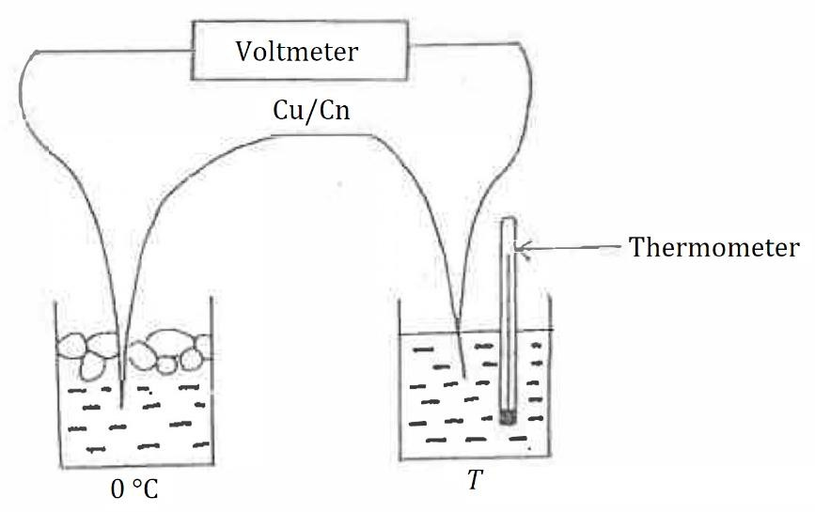

**Figure 3:** EMF measurement of a Cu/Cn thermocouple.

### Measurement

1. Connect the circuit as shown in **Figure 3**, using the Cu/Cn thermocouple.
2. Set the temperature of the cold junction in the beaker as 0 °C. The temperatures can be varied between 0–100 °C by either adding ice into the beakers or switching on the heater.
3. Setting the same temperature (𝑇 = 0 °C) at the hot junction, obtain the thermocouple's electromotive force (EMF, 𝐸) and record it in **Table 2**.
4. Repeat **Steps 2-3** by increasing the temperature from 0 °C to 100 °C in steps of 10 °C. For every measurement, observe and record whether the thermocouple's hot junction is connected to the positive or negative terminal of the digital multimeter.*
5. Repeat **Steps 2-4** (measurement of EMF) for all the remaining thermocouples (Cu/Fe and Cn/Fe) provided.

**\****The EMF of the thermocouple is considered as positive if the potential of hot junction is positive compared to the potential of cold junction. On the other hand, EMF of the thermocouple is considered as a negative if the potential of hot junction is negative compared to the potential of cold junction.*

### Analysis

1. Plot the EMF vs. temperature for the three thermocouples on the same graph paper. The sign of the EMF for each thermocouple must be shown clearly.
2. Calculate the Seebeck coefficients 𝛼Cu/Cn, 𝛼Cu/Fe and 𝛼Cn/Fe from the graphs and their respective uncertainties.
3. Compare and find the percentage discrepancy between your experimental values and the

standard values as follows: 𝛼Cu/Cn = 40.87 µV °C−1 , 𝛼Cu/Fe = −13.89 µV °C−1 , and

𝛼Cn/Fe = −54.76 µV °C−1.

1. Verify the law of intermediate materials with the experimental data.

**Table 2**: EMF of Cu/Cn, Cu/Fe and Cn/Fe thermocouples as a function of temperature.

|  |  |  |  |  |  |
| --- | --- | --- | --- | --- | --- |
| **Cu/Cn** | | **Cu/Fe** | | **Cn/Fe** | |
| **Voltage**: + / – | | **Voltage**: + / – | | **Voltage**: + / – | |
| **Temperature**  **(°C)** | **EMF**  **(μV)** | **Temperature**  **(°C)** | **EMF**  **(μV)** | **Temperature**  **(°C)** | **EMF**  **(μV)** |
|  |  |  |  |  |  |
|  |  |  |  |  |  |
|  |  |  |  |  |  |
|  |  |  |  |  |  |
|  |  |  |  |  |  |
|  |  |  |  |  |  |
|  |  |  |  |  |  |
|  |  |  |  |  |  |
|  |  |  |  |  |  |
|  |  |  |  |  |  |
|  |  |  |  |  |  |

## Part B: The Characteristics of A Thermocouple Between 0–400 °C

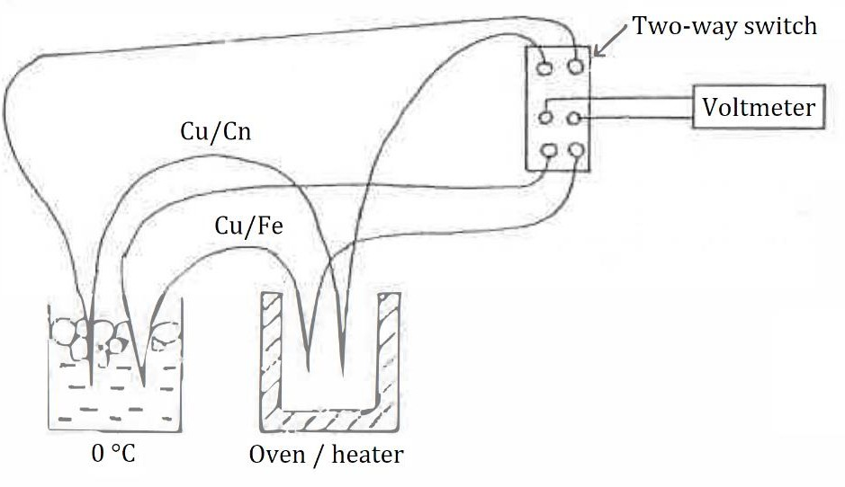

**Figure 4:** EMF measurement for the Cu/Fe thermocouple at temperatures up to 400 °C. The Cu/Cn thermocouple is used as a thermometer.

### Measurement

1. Connect the circuit as shown in **Figure 4** (cold junction remains at 0 °C). When the heater is switched on, the temperature will decrease at a rate of 5 °C per minute. Therefore, the temperature (Cu/Cn thermocouple) and EMF (Cu/Fe thermocouple) must be recorded quickly.
2. Read the EMF of the Cu/Cn thermocouple, then change the two-way switch immediately.
3. Read the EMF of the Cu/Fe thermocouple, then change the two-way switch immediately.
4. Read the EMF of the Cu/Cn thermocouple once again.
5. Obtain the average value of the EMF for Cu/Cn (**Steps 2** and **4**), then find the equivalent temperature for that particular EMF from **Table A1** in the **APPENDIX**.**
6. Record your readings in **Table 3**.
7. Repeat **Steps 2-5** using different Cu/Cn temperatures, such that the change in EMF in the Cu/Cn thermocouple is ~1 mV until you reach a reading of 𝑬𝐂𝐮/𝐂𝐧 ~21 mV (~400⸰C).

*\*\*Here we assume that in such a short time interval, the temperature increases linearly. The temperature of the* Cu/Fe *thermocouple (*𝑇2*) is taken to be in between the initial and the final readings, so that we can approximate the average* Cu/Cn *thermocouple temperature to be*

### Analysis

𝑇avg =

𝑇1 + 𝑇3

2 ≈ 𝑇2.

1. Plot the graph of Cu/Fe thermocouple EMF (𝐸) vs. temperature (𝑇).
2. From this graph, determine the neutral temperature (𝑇n) and inversion temperature (𝑇i) for the Cu/Fe thermocouple.
3. Compare and find the percentage discrepancies between the experimental values and the standard values of 𝑇n = 285 °C and 𝑇i = 570°C.
4. From Cu/Fe thermocouple EMF (𝐸) vs. temperature (𝑇) graph, determine 𝑑𝐸/𝑑𝑇 for each point, and record them down in **Table 4**. Make an assumption that 𝑑𝐸/𝑑𝑇 ≈ Δ𝐸/Δ𝑇, where Δ𝐸 is a small change in 𝐸 over a certain range of Δ𝑇 (such as +25 °C and -25 °C from each point).
5. Plot the graph of 𝑑𝐸/𝑑𝑇 vs. 𝑇, and find the values of 𝛼, 𝛽 and 𝑇n from it.
6. From your graph of 𝐸 vs. 𝑇, calculate 𝐸/𝑡 for some values of 𝑇 (in steps of ~25 °C) and tabulate the values in **Table 5**.
7. Plot the graph of 𝐸/𝑇 vs. 𝑇, and identify the values of 𝛼, 𝛽 and 𝑇n from the graph.
8. Verify if 𝑇i

= 2𝑇n, and if the equation

1

𝐸 = 𝛼𝑇 +  𝛽𝑇

2

2 is suitable to explain thermoelectric

effects of the Cu/Fe thermocouple in the temperature range of 0–400 °C.

**Table 3**: EMF (𝐸) of the Cu/Fe thermocouple as a function of temperature (𝑇).

|  |  |  |
| --- | --- | --- |
| **EMF of Cu/Cn,**  𝑬𝐂𝐮/𝐂𝐧 **(μV)** | **Corresponding**  **Temperature (**𝑻**, °C)** | **EMF of Cu/Fe,**  𝑬 **(μV)** |
|  |  |  |
|  |  |  |
|  |  |  |
|  |  |  |
|  |  |  |
|  |  |  |
|  |  |  |
|  |  |  |
|  |  |  |
|  |  |  |
|  |  |  |
|  |  |  |
|  |  |  |
|  |  |  |
|  |  |  |
|  |  |  |
|  |  |  |
|  |  |  |
|  |  |  |
|  |  |  |
|  |  |  |

**Table 4**: 𝑑𝐸/𝑑𝑇 as a function of 𝑇.

|  |  |  |  |  |  |
| --- | --- | --- | --- | --- | --- |
| **Temperature,**  ***T***  **(**°𝐂**)** | 𝚫𝑻  **(°C)** | 𝚫𝑬  **(μV)** | | | 𝒅𝑬 𝚫𝑬  ≈  𝒅𝑻 𝚫𝑻  **(**𝛍𝐕 °𝐂−𝟏**)** |
| 𝑬 (𝑻 + 𝟐𝟓) | 𝑬 (𝑻 − 𝟐𝟓) | 𝚫𝑬 |
| 25 | 50 |  |  |  |  |
| 50 | 50 |  |  |  |  |
| 75 | 50 |  |  |  |  |
| 100 | 50 |  |  |  |  |
| 125 | 50 |  |  |  |  |
| 150 | 50 |  |  |  |  |
| 175 | 50 |  |  |  |  |
| 200 | 50 |  |  |  |  |
| 225 | 50 |  |  |  |  |
| 250 | 50 |  |  |  |  |
| 275 | 50 |  |  |  |  |
| 300 | 50 |  |  |  |  |
| 325 | 50 |  |  |  |  |
| 350 | 50 |  |  |  |  |
| 375 | 50 |  |  |  |  |
| 400 | 50 |  |  |  |  |
|  |  |  |  |  |  |
|  |  |  |  |  |  |
|  |  |  |  |  |  |
|  |  |  |  |  |  |

**Table 5**: Values of 𝐸/𝑇 for their corresponding temperatures 𝑇.

|  |  |  |
| --- | --- | --- |
| **Temperature,**  𝑻 **(**°𝐂**)** | **EMF,**  𝑬 **(μV)** | 𝑬/𝑻 **(**𝛍𝐕 °𝐂−𝟏**)** |
|  |  |  |
|  |  |  |
|  |  |  |
|  |  |  |
|  |  |  |
|  |  |  |
|  |  |  |
|  |  |  |
|  |  |  |
|  |  |  |
|  |  |  |
|  |  |  |
|  |  |  |
|  |  |  |
|  |  |  |
|  |  |  |

## Part C: Thermal Conductivity Measurements for Solid Materials

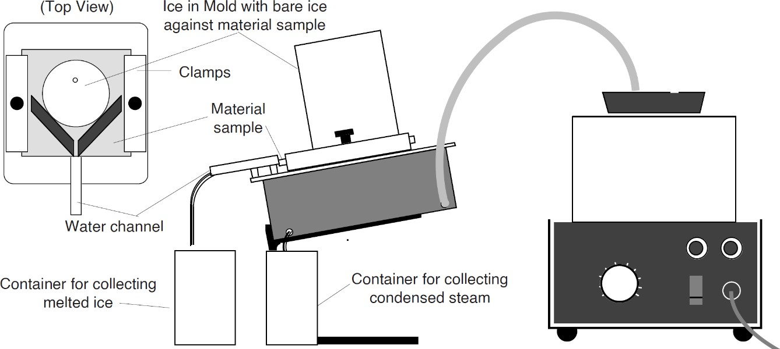

**Figure 5**: Experimental setup for **Part C**.

### Measurement

1. Fill the plastic cup with water and place it inside the freezer (with the cover open).
2. Once the water is frozen, wash the cup slightly to loosen the ice inside the cup (do not take the ice out of the cup yet).
3. Measure and record the thickness ℎ of the Masonite (wood fibre board) in **Table 6**.
4. Place the Masonite onto the steam chamber as shown in **Figure 5**. Apply gel to the area between the sample and the surface of the container before tightening the thumbscrews to prevent leakage of water later.
5. Measure and record the diameter of the ice block as 𝑑1.
6. Without removing from the cup, put the ice block onto the Masonite as shown in **Figure**
7. Make sure the ice is in direct contact with the sample.
8. Leave the ice on the Masonite for 1–2 minutes until the ice starts to melt and water begins to drip out. Do not start collecting data before the ice melt!
9. Follow the instructions below when collecting data from the ice and water:
   1. Determine the mass of the container used to collect the water that drips from the melting ice.
   2. Determine the time taken to collect a specified amount of water, 𝑡a. (~10 minutes).
   3. Weigh the container together with the water collected and record the reading.
   4. Subtract the mass of the empty container from the value to determine the mass of the collected water (𝑚ws).
10. Switch on the steam chamber. Let the steam out for a few minutes until its temperature is stable (place a container at the spot where the water drips).
11. Empty the container used to collect water from the melted ice.
12. Repeat **Step 7** to obtain readings when steam from the steam chamber is used.
13. Measure and record the weight of the water dripping from melting ice as 𝑚w, and the time taken, 𝑡 (5-10 minutes).
14. Measure the diameter of the ice block again and record it as 𝑑2.
15. Repeat the experiment by replacing Masonite with wood, Lexan, rock and glass.

### Analysis

1. Take the average of 𝑑1 and 𝑑2 to obtain 𝑑avg, the mean diameter for the ice block during the experiment.
2. Use 𝑑avg to determine the value of 𝐴, the area where the heat moves between the ice and

vapour container. (the area where the surface of the block is in contact with the surface of the sample).

1. Calculate 𝑅a = 𝑚wa/𝑡a and 𝑅 = 𝑚w/𝑡, which are the rates of ice melting before and after the steam is used, respectively.
2. Calculate 𝑅0 = 𝑅 − 𝑅a, which is the rate of the ice melting in the experiment.
3. Calculate 𝑘, the conductivity of the sample (in cal cm−1 s−1 °C−1):

𝑅0ℎ × 80 cal g−1

𝑘 =

.

𝐴Δ𝑇

Take Δ𝑇 to be the boiling point of water at 1 atmospheric pressure.

**Table 6**: Data for Part C.

|  |  |  |  |  |  |  |  |  |  |  |  |  |
| --- | --- | --- | --- | --- | --- | --- | --- | --- | --- | --- | --- | --- |
| **Material** | 𝒉 | 𝒅𝟏 | 𝒅𝟐 | 𝒕𝐚 | 𝒎𝐰𝐚 | 𝒕 | 𝒎𝐰 | 𝒅𝐚𝐯𝐠 | 𝑨 | 𝑹𝐚 | 𝑹 | 𝑹𝟎 |
| Masonite |  |  |  |  |  |  |  |  |  |  |  |  |
| Wood |  |  |  |  |  |  |  |  |  |  |  |  |
| Lexan |  |  |  |  |  |  |  |  |  |  |  |  |
| Rock |  |  |  |  |  |  |  |  |  |  |  |  |
| Grass |  |  |  |  |  |  |  |  |  |  |  |  |

# REFERENCES

1. Lewis, K. (2017). *Thermocouple Laws.* Retrieved 4 Aug 2021 from [sciencing.com.](https://sciencing.com/about-5405627-thermocouple.html)
2. Northwestern University (n. d.). *Brief History of Thermoelectrics.* Retrieved 4 Aug 2021 from [thermoelectrics.matsci.northestern.edu.](http://thermoelectrics.matsci.northwestern.edu/thermoelectrics/history.html)
3. Quest Tutorials (n. d.). *Thermoelectric Effect of Current*. Retrieved 4 Aug 2021 from [questtutorials.com.](https://www.questtutorials.com/media/static/xii/physics/03_Thermal%20and%20Chemical%20effects%20of%20current/04_Thermoelectric%20effect%20of%20current.htm)
4. Study.com (n. d.). What is Neutral Temperature? Retrieved 4 Aug 2021 from [study.com.](https://study.com/academy/answer/what-is-neutral-temperature.html)
5. PASCO (1987). Instruction Manual for the *Thermal Conductivity Apparatus* (TD-8561).

# ACKNOWLEDGEMENT

This lab manual was originally created by *T. S. T., K. W. K., L. B. S.*, *L. S. H.* and *Emeritus Prof. Dr. Lim Koon Ong* in 1996, translated by *A. Prof. Quah Ching Kheng* and *I. M.* in 2009. This manual was revamped and standardised by *Dr. John Soo Yue Han* in 2021.

*Last Updated*: 04 April 2022 (JSYH)

# APPENDIX

**Table A1** : Thermoelectric voltage (mV) for Cu/Cn thermocouple hot junction at temperature 0–400 °C, reference junction at 0 °C.

|  |  |  |  |  |  |  |  |  |  |  |
| --- | --- | --- | --- | --- | --- | --- | --- | --- | --- | --- |
| **Temperature**  **(°C)** | **0** | **1** | **2** | **3** | **4** | **5** | **6** | **7** | **8** | **9** |
| **0** | 0.000 | 0.039 | 0.078 | 0.117 | 0.156 | 0.195 | 0.234 | 0.273 | 0.312 | 0.352 |
| **10** | 0.391 | 0.431 | 0.470 | 0.510 | 0.549 | 0.589 | 0.629 | 0.669 | 0.709 | 0.749 |
| **20** | 0.790 | 0.830 | 0.870 | 0.911 | 0.951 | 0.992 | 1.033 | 1.074 | 1.114 | 1.155 |
| **30** | 1.196 | 1.238 | 1.279 | 1.320 | 1.362 | 1.403 | 1.445 | 1.486 | 1.528 | 1.570 |
| **40** | 1.612 | 1.654 | 1.696 | 1.738 | 1.780 | 1.823 | 1.865 | 1.908 | 1.950 | 1.993 |
| **50** | 2.036 | 2.079 | 2.122 | 2.165 | 2.208 | 2.251 | 2.294 | 2.338 | 2.381 | 2.425 |
| **60** | 2.468 | 2.512 | 2.556 | 2.600 | 2.643 | 2.687 | 2.732 | 2.776 | 2.820 | 2.864 |
| **70** | 2.909 | 2.953 | 2.998 | 3.043 | 3.087 | 3.132 | 3.177 | 3.222 | 3.267 | 3.312 |
| **80** | 3.358 | 3.403 | 3.448 | 3.494 | 3.539 | 3.585 | 3.631 | 3.677 | 3.722 | 3.768 |
| **90** | 3.814 | 3.860 | 3.907 | 3.953 | 3.999 | 4.046 | 4.092 | 4.138 | 4.185 | 4.232 |
| **100** | 4.279 | 4.325 | 4.372 | 4.419 | 4.466 | 4.513 | 4.561 | 4.608 | 4.655 | 4.702 |
| **110** | 4.750 | 4.798 | 4.845 | 4.893 | 4.941 | 4.988 | 5.036 | 5.084 | 5.132 | 5.180 |
| **120** | 5.228 | 5.277 | 5.325 | 5.373 | 5.422 | 5.470 | 5.519 | 5.567 | 5.616 | 5.665 |
| **130** | 5.714 | 5.763 | 5.812 | 5.861 | 5.910 | 5.959 | 6.008 | 6.057 | 6.107 | 6.156 |
| **140** | 6.206 | 6.255 | 6.305 | 6.355 | 6.404 | 6.454 | 6.504 | 6.554 | 6.604 | 6.654 |
| **150** | 6.704 | 6.754 | 6.805 | 6.855 | 6.905 | 6.956 | 7.006 | 7.057 | 7.107 | 7.158 |
| **160** | 7.209 | 7.260 | 7.310 | 7.361 | 7.412 | 7.463 | 7.515 | 7.566 | 7.617 | 7.668 |
| **170** | 7.720 | 7.771 | 7.823 | 7.874 | 7.926 | 7.977 | 8.029 | 8.081 | 8.133 | 8.185 |
| **180** | 8.237 | 8.289 | 8.341 | 8.393 | 8.445 | 8.497 | 8.550 | 8.602 | 8.654 | 8.707 |
| **190** | 8.759 | 8.812 | 8.865 | 8.917 | 8.970 | 9.023 | 9.076 | 9.129 | 9.182 | 9.235 |
| **200** | 9.288 | 9.341 | 9.395 | 9.448 | 9.501 | 9.555 | 9.608 | 9.662 | 9.715 | 9.769 |
| **210** | 9.822 | 9.876 | 9.930 | 9.984 | 10.038 | 10.092 | 10.146 | 10.200 | 10.254 | 10.308 |
| **220** | 10.362 | 10.417 | 10.471 | 10.525 | 10.580 | 10.634 | 10.689 | 10.743 | 10.798 | 10.853 |
| **230** | 10.907 | 10.962 | 11.017 | 11.072 | 11.127 | 11.182 | 11.237 | 11.292 | 11.347 | 11.403 |
| **240** | 11.458 | 11.513 | 11.569 | 11.624 | 11.680 | 11.735 | 11.791 | 11.846 | 11.902 | 11.958 |
| **250** | 12.013 | 12.069 | 12.125 | 12.181 | 12.237 | 12.292 | 12.349 | 12.405 | 12.461 | 12.518 |
| **260** | 12.574 | 12.630 | 12.687 | 12.743 | 12.799 | 12.856 | 12.912 | 12.969 | 13.026 | 13.082 |
| **270** | 13.139 | 13.196 | 13.253 | 13.310 | 13.366 | 13.423 | 13.480 | 13.537 | 13.595 | 13.652 |
| **280** | 13.709 | 13.766 | 13.823 | 13.881 | 13.938 | 13.995 | 14.053 | 14.110 | 14.168 | 14.226 |
| **290** | 14.283 | 14.341 | 14.399 | 14.456 | 14.514 | 14.572 | 14.630 | 14.688 | 14.746 | 14.804 |
| **300** | 14.862 | 14.920 | 14.978 | 15.036 | 15.095 | 15.153 | 15.211 | 15.270 | 15.328 | 15.386 |
| **310** | 15.445 | 15.503 | 15.562 | 15.621 | 15.679 | 15.738 | 15.797 | 15.856 | 15.914 | 15.973 |
| **320** | 16.032 | 16.091 | 16.150 | 16.209 | 16.268 | 16.327 | 16.387 | 16.446 | 16.505 | 16.564 |
| **330** | 16.624 | 16.683 | 16.742 | 16.802 | 16.861 | 16.921 | 16.980 | 17.040 | 17.100 | 17.159 |
| **340** | 17.219 | 17.279 | 17.339 | 17.399 | 17.458 | 17.518 | 17.578 | 17.638 | 17.698 | 17.759 |
| **350** | 17.819 | 17.879 | 17.939 | 17.999 | 18.060 | 18.120 | 18.180 | 18.241 | 18.301 | 18.362 |
| **360** | 18.422 | 18.483 | 18.543 | 18.604 | 18.665 | 18.725 | 18.786 | 18.847 | 18.908 | 18.969 |
| **370** | 19.030 | 19.091 | 19.152 | 19.213 | 19.274 | 19.335 | 19.396 | 19.457 | 19.518 | 19.579 |
| **380** | 19.641 | 19.702 | 19.763 | 19.825 | 20.886 | 20.947 | 20.009 | 20.070 | 20.132 | 20.193 |
| **390** | 20.255 | 20.317 | 20.378 | 20.440 | 20.502 | 20.563 | 20.625 | 20.687 | 20.748 | 20.810 |
| **400** | 20.872 |  |  |  |  |  |  |  |  |  |